Steps to Fill BHU application form for UET
Step 1. Registration
- Visit the official website of BHU and click on ‘Apply for Admission’ for registration.
- Click on ‘Register Yourself’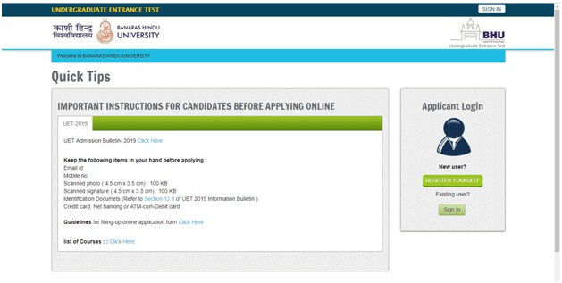
- Enter the details such as Email ID, password, personal details. Then, click on ‘Sign up’ option.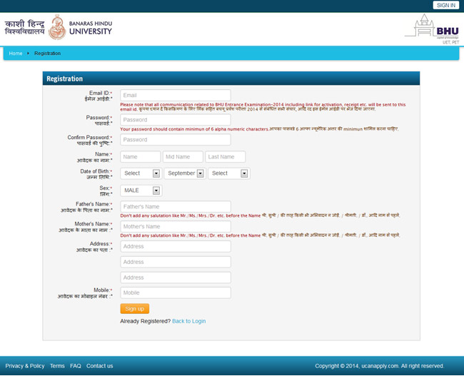
Step 2. Filling the Identification Details
- Candidates need to provide every detail in this section in a proper way. This section is for the identification of the candidate’s identity.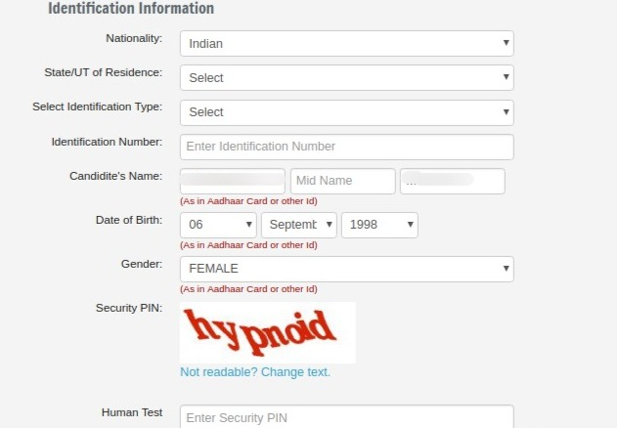
Step 3. Course-selection
- Applicants have to select the course/programmes for which they wish to apply for. In order to know the eligibility criteria of the selected course, the candidates may also click on ‘Check Eligibility’ to know if they are eligible.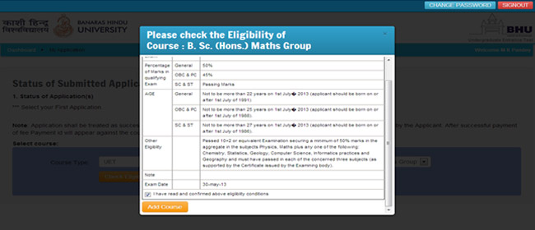
Step 4. Filling up the BHU UET 2020 application form
- Candidates have to fill information such as personal details, academic qualifications, address etc.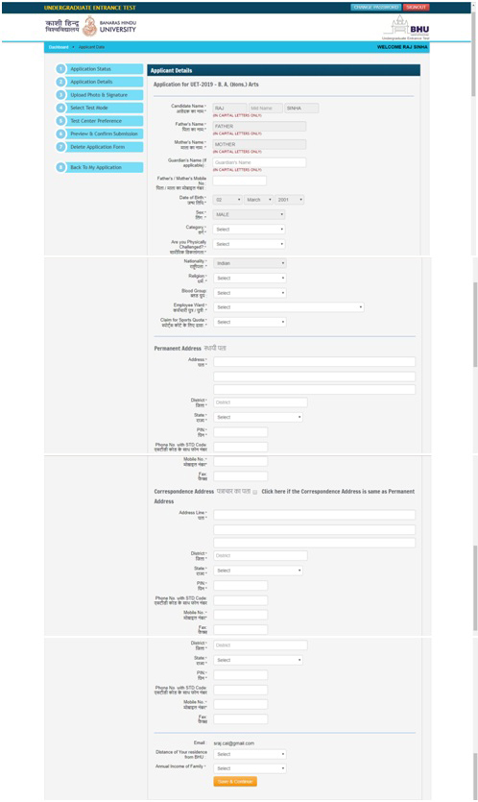
Step 5. Choose the examination centres
- Up to five BHU UET exam centres can be chosen by candidates in their BHU application form for UET. Applicants need to choose the exam centres according to their preferences and convenience.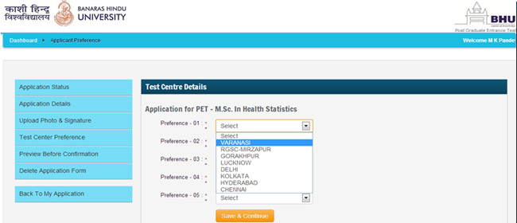
Step 6. Upload the documents
- Upload scanned images of your coloured photographs and signature according to the dimensions prescribed by the university.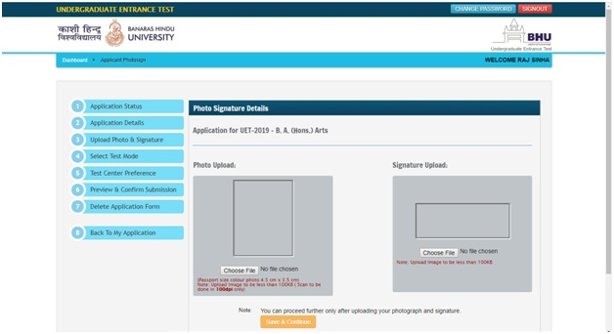
Step 7. Review the BHU UET application form 2020
- It is suggested that the candidates check their application form of BHU UET 2020 carefully before submitting it for the payment. Once the candidates are satisfied with the details filled in their application form, they can click on ‘Confirm and submit’.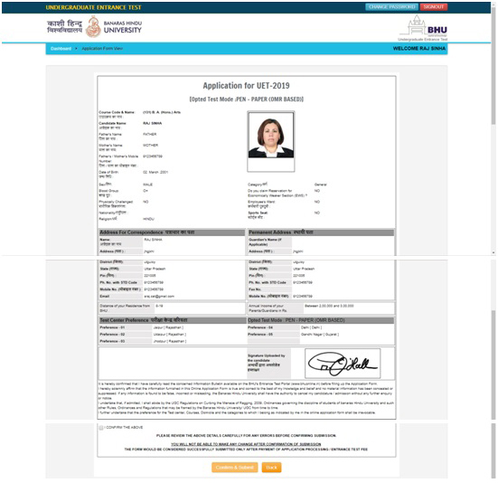
Step 8. Remit the BHU UET application fee
- Candidates can pay their application fee online via Debit Card/Credit Card/Net Banking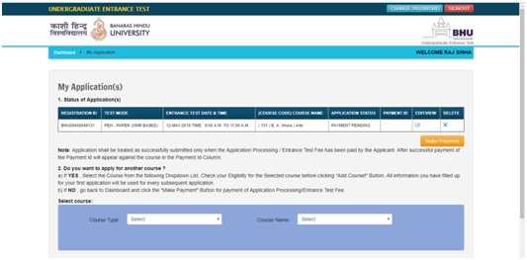
- Applicants also have the facility to pay the fee via ‘Challan’ that will be received after making the requisite fee in any of the HDFC branches. After getting the Student’s copy of your ‘Challan’, upload its scanned image online.
